

Pan-European Master Plan on Active Mobility
  - Subtitle optional
Vienna, 2026

Legal notice
Media owner, publisher, editor:
Federal Ministry of Innovation, Mobility and Infrastructure, Radetzkystraße 2, 1030 Vienna, Austria
Authors: XXX
Editorial: Division/Department XXX
Photo credits: Cover: unplash.com/Ferdinand Stöhr
Print: XXX
Vienna, 2026. Last updated: 12 March 2026
Copyright and Liability:
Copies may only be made of extracts where there is a reference to the source; all other rights reserved. Reference is made to the fact that despite careful processing all information provided in this publication is subject to correction and liability on the part of the Chancellery and the author is excluded. The legal opinions expressed represent the non-binding opinions of the author and in no way anticipate the jurisdiction of independent courts.
Feedback: If you would like to share any feedback about this brochure, please contact empfaenger@bmimi.gv.at.

Foreword/Preface/Preamble

Vorname Nachname
Insert/write foreword…
Insert image via button and insert alt text. Prepare the image before insert: 3.8 cm width and 4.7 cm height.
Remove “Positionsrahmen” if no image is used.
Name
Function (or one line for both)

Table of Contents
Foreword/Preface/Preamble 3
1 Introduction 5
2 Vision & Objectives 6
2.1 Definition of Active Mobility 6
2.2 Importance of Active Mobility 6
2.3 Vision Statement 7
2.4 Objectives 7
3 Thinking Walking and Cycling Together 9
3.1 Connecting Walking and Cycling 9
3.2 Benefits of Active Mobility 9
4 Joining forces with public and other modes of transport 12
4.1 Active Mobility as the most natural form of mobility 12
4.2 Integration with Public Transport (PT) 12
4.3 Integration with Micro Mobility 14
4.4 Integration with Shared Mobility 15
4.5 Urban Design 16
5 Recommendation for joint planning - Master Plan Cycling and Master Plan Walking 18
Table of Tables 19
Table of Figures 20
Bibliography 21
Abbrevations 24

- Introduction
The Transport, Health and Environment Pan-European Programme – THE PEP is a joint Programme of WHO Europe and the United Nations Economic Commission for Europe (UNECE). It was established as a policy platform to strengthen cooperation between the transport, environment and health ministries across the pan-European region, as well as with other key international organisations. The THE PEP EHP Partnership on Active Mobility is led by Austria, France and The Netherlands and jointly supported by UNECE and WHO. The Partnership supports countries in promoting walking and cycling by connecting national ministries, local governments, researchers and NGOs. It provides access to expertise, good practices, pilot activities and coordinated policy guidance. The aim is to embed health-promoting, climate-friendly mobility —both in national strategies and in local implementation. The Vienna Declaration (2021) is a commitment by pan-European countries to “build forward better” by transforming transport systems towards clean, safe, healthy, inclusive and climate-friendly mobility, with a strong focus on active modes such as walking and cycling. It sets objectives for the year 2030 to significantly increase cycling and walking, extend and improve safe infrastructure, and develop national cycling and walking policies and plans in every country.
The Declaration also calls for a pan-European Master Plan for Active Mobility. In this context, the Pan-European Master Plan for Cycling Promotion (2021) and the Pan-European Master Plan on Walking (2024) provide the foundational policy frameworks. An overarching Active Mobility perspective builds on and connects these two Master Plans, supporting the coordinated integration of walking and cycling into transport, health, environment and spatial planning policies. The Master Plan on Active Mobility is designed as a strategic framework and guide, rather than an operational plan. It provides pan-European countries with a consolidated perspective on walking and cycling, highlighting their synergies and integration with public transport. Readers are encouraged to use the document to understand the overarching principles, and recommendations. By strengthening walking and cycling, pan-European countries can build more coherent, effective, and impactful policies that support healthier, safer, and more sustainable transport systems.
- Vision & Objectives
  - Definition of Active Mobility
Active mobility refers to all forms of human-powered movement, that enable people to reach everyday destinations safely, independently, and sustainably. As the most universal and accessible modes of transport, walking and cycling form the foundation of healthy, zero-emission mobility systems and play a central role in achieving climate, public health, and social inclusion goals.
In the context of this Master Plan, active mobility refers to walking and cycling. Thinking walking and cycling together is essential because both modes share the same objectives — health, sustainability, accessibility, and safety — and rely on the limited urban space. A joint approach avoids siloed planning, reduces competition between modes, and enables coherent, human-centred mobility systems in which walking and cycling complement each other. By integrating both modes within an active mobility perspective, countries, regions and cities can maximise benefits, improve efficiency, and create more active people and more liveable, inclusive environments for all.
  - Importance of Active Mobility
Active mobility the most accessible choice of movement for most people. There is no end to the diversity of people who walk and cycle, and includes all age groups and genders, a wide range of physical and mental abilities, income, and ethnicity.
Active mobility is important for trips from A to B but also as a link to other modes of transport. But most travel surveys, whether conducted at a national or local level, collect solely data on the mode of transport that covers the longest distance within a journey. This approach obscures the significance and nature of shorter trip legs that are inherent in most travel. In the European Union (27 countries) ranges the modal split for active mobility between 4,9 % and 7,8 % (Eurostat 2026, own calculation).
  - Vision Statement
The vision of the Master Plan on Active Mobility is to enable everyone in the region to have safe, accessible, comfortable and enjoyable walking and cycling experiences.
Mobility planning should prioritize active mobility (see Figure 1; WHO 2022). Healthier, zero-emission options like walking and cycling must take precedence over polluting or energy-intensive modes such as private cars or shared motor vehicles. Unlike traditional car-focused planning, integrated sustainable mobility policy’s view walking, cycling, public transport and shared mobility as the primary modes—especially since most trips in European cities are under five kilometres (BMVIT 2016).
Figure 1 Sustainable mobility pyramid: prioritizing healthy, green and sustainable mobility
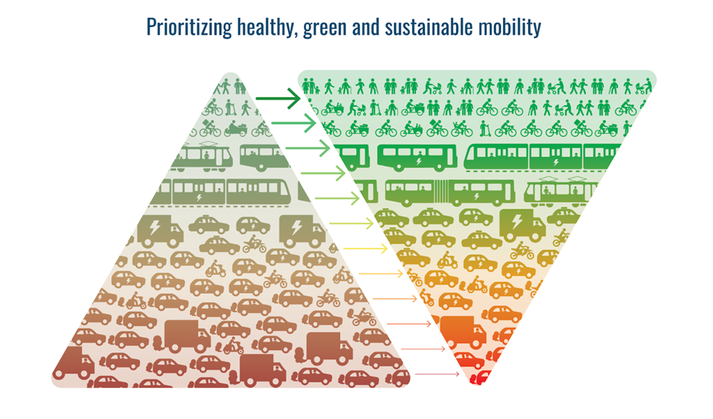
Source: WHO Regional Office for Europe, Walking and Cycling: Latest Evidence to Support Policymaking and Practice (Copenhagen, 2022), p. 9.
  - Objectives
The Master Plan on active mobility contributes and commit to achieving the following objectives by 2030 from the Vienna Declaration:
  - Significantly increase cycling and walking in every country and contribute to the overall target of doubling cycling in the region as a whole;
  - Extend and improve infrastructure for safe cycling and walking in every country in the region, including safe mobility for children and youth to kindergartens, schools and in neighbourhoods;
  - Develop and implement national cycling and walking policies, supported by national cycling and walking plans, strategies and programmes, including the setting of national targets, in every country in the region, and also promote their implementation in relevant subnational plans and policies;
  - Significantly improve the safety of cyclists and pedestrians in every country in the region and significantly reduce the number of fatalities and serious injuries amongst these road users in the region as a whole;
  - Integrate cycling and walking into health policies, as well as transport infrastructure and land-use planning;
- Thinking Walking and Cycling Together
  - Connecting Walking and Cycling
From a technical and strategic perspective, a Master Plan on active mobility provides a necessary overarching framework to address walking and cycling in an integrated and coherent way. Treating them separately risks fragmented planning, inconsistent design standards, and competition for limited public space. A unified active mobility framework enables alignment of goals, principles, and performance indicators, supports coordinated governance and investment, and ensures consistency across national, regional, and local levels.
Importantly, active mobility strengthens the resilience of transport systems by providing low-cost, energy-independent, and adaptable mobility options that remain functional during crises such as energy shortages, or disruptions to motorised transport. By building on and connecting the existing Master Plans on walking and cycling, a Master Plan on active mobility creates added value by improving system robustness, fostering synergies, and maximising the overall impact of active mobility policies.
  - Benefits of Active Mobility
Thinking walking and cycling together maximizes their combined impacts on health, environment, equity/social inclusion, economy, and urban quality. Walking forms the foundation of all mobility and cycling extends the range and speed of human-powered mobility. Both active modes share common goals of reducing greenhouse gas emissions, improving public health through physical activity, promoting safe and inclusive mobility, local economic prosperity, sustainable tourism and enhancing liveable urban spaces (see Figure 2; WHO 2022).
When planned jointly, walking and cycling enable a more integrated approach to sustainable transport, strengthening the shift away from motorised vehicles and contributing to greater reductions in air pollution, noise, and traffic congestion. Coordinated promotion of both modes also increases the political visibility and legitimacy of active mobility policies, creating synergies in funding, infrastructure development, and public awareness initiatives. In addition, a joint approach can support more coherent regulatory and legislative frameworks, including adaptations to traffic codes, liability and third-party insurance rules, and speed management policies — for example enabling local authorities to introduce 30 km/h zones or default urban speed limits where appropriate. Aligning policy, infrastructure, and legal frameworks helps create safer conditions for pedestrians and cyclists while strengthening the overall effectiveness of active mobility strategies
Figure 2 Mapping out the benefits of walking and cycling (WHO)
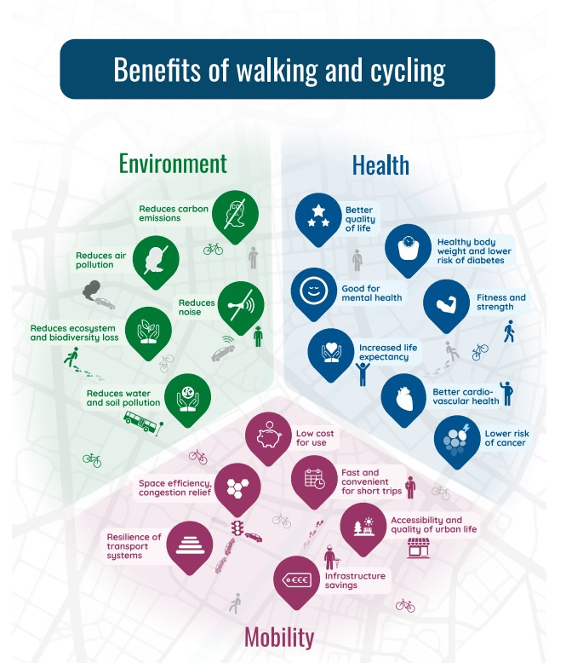
Source: WHO, Walking and Cycling.
Common key benefits and synergies between walking and cycling (PATH 2022, Masterplan Cycling 2021, Masterplan Walking 2022):
- Health & Well-being: Walking or cycling for 20 - 30 minutes per day provides major long-term health gains, reducing risks of heart disease, diabetes, cancer, obesity, depression, dementia, and premature mortality. This aligns with the World Health Organization (WHO) recommendation of at least 150 minutes of moderate-intensity physical activity per week, which can be effectively achieved through everyday walking and cycling. Active mobility is one of the most effective, low-cost population-level health interventions.
  - When walking and cycling are planned together, daily physical activity becomes easier to integrate into everyday routines, increasing participation and long-term health impacts across the population.
- Climate & Environmental Benefits: Walking and cycling emit no CO₂ and require minimal energy. Shifting car trips to active mobility is one of the fastest and most cost-effective ways to cut greenhouse gas emissions, reduce air pollution, and decrease noise exposure.
  - A joint approach strengthens this impact by offering coherent, reliable alternatives to car use, rather than isolated mode-specific solutions.
- Economic Efficiency & Cost Savings: Many urban trips are short: approximately 40 % are under 0,5 km and around 25 % under 1 km (BMVIT 2016). These are distances easily served by walking or cycling — especially with e-bikes, which extend feasible ranges. Replacing car trips reduces congestion, lowers household transport costs, and avoids expensive road infrastructure investments.
  - Thinking of both modes together maximizes coverage of these short trips and ensures seamless transitions between walking and cycling, improving overall system efficiency.
- Social Inclusion & Equity: Walking and cycling are affordable, accessible modes available to nearly all population groups. As pedestrian cyclist you are more in control and more connected with the environment. Joint planning ensures infrastructure also meets the needs of children, older adults, people with disabilities, and lower-income households, supporting fair access to jobs, services, and community life. They effectively address transport poverty.
  - By considering both modes together, barriers between user groups are reduced and are strengthened across all ages and abilities.
- Liveable, Human-Scale Urban Spaces: Walking and cycling place people at the center of mobility. Together with traffic calming, streets become safer, calmer, and more attractive, stimulating local businesses, outdoor activity, and social interaction. High-quality public spaces support mental well-being and improve urban life. Residential neighborhoods become walkable and cyclable, reducing the demand for expensive car parking, hereby making housing more affordable.
  - Coordinated planning for pedestrians and cyclists helps transform streets from traffic corridors into shared public spaces that serve multiple social and economic functions.
- Efficient Use of Space: Thinking walking and cycling together optimises the use of urban space. It enables effective allocation of limited urban space, reducing conflicts and enabling smooth transitions between walking and cycling environments.
  - This is particularly important in dense urban areas, where balanced design solutions can accommodate both modes without compromising safety or comfort.
- Safety Reinforcement: The “safety in numbers” effect shows that as more people walk and cycle, crash rates per user decrease (Jacobsen 2004). Joint planning increases visibility and priority for vulnerable road users, making streets safer overall.
  - When walking and cycling are promoted together, they reinforce each other’s presence in traffic, strengthening safety outcomes for all road users.
- Joining forces with public and other modes of transport
  - Active Mobility as the most natural form of mobility
Walking and cycling form the backbone of the mobility system. Their effectiveness increases significantly when they are well integrated with public transport, shared mobility services, micro mobility, and urban design. Together, these modes create a coherent system that offers attractive alternatives to private car use across all trip lengths.
Walking and cycling are the most efficient modes for short distances. When combined with public transport or shared mobility, they also become a strong alternative for medium and longer journeys. Walking and cycling are indispensable for accessing buses, trams, trains and other mobility options (e.g. car-/bike-sharing). Good walking and cycling accessibility significantly expand the catchment area of public transport stops, stations and sharing hubs. Integrating shared mobility reduces furthermore car dependency and promote flexible, multimodal journeys. This shift supports climate goals, reduces car dependence, and improves quality of life.
  - Integration with Public Transport (PT)
Seamless integration with public transport relies on safe, comfortable, and continuous walking and cycling routes, particularly around stops and stations. 90 % of passengers arrive at PT stations using walking - looking at requirements of cyclists and pedestrians at and in the surrounding of stations is beneficial for almost all PT passengers. By improving the link between active modes and PT provides a valid trip option even for mid-range and long-distance trips. The size of the potential user base therefore depends largely on how far people are willing to walk and cycle— a factor strongly influenced by the quality and directness of the environment. (Hillnhütter 2016)
In pedestrian-oriented urban areas, users are willing to walk up to 70 % longer distances to reach transit compared with car-dominated environments, independent of detours. Green spaces and pedestrian streets increase acceptable walking distances by about 10 %, and lively urban squares with active facades can extend acceptable walking distances by up to 17 %. Furthermore, nearly 45 % of regular public transport users combine their trip with accessing destinations along the way, and the presence of shops, services, or amenities can encourage people to walk 15–25 % longer to a public transport stop. (Hillnhütter 2016, Walk21 2024)
High-quality bicycle infrastructure at and around public transport nodes is a key element of integrated mobility systems. Cycling enhances access to stations and supports first/last-mile connections, while public transport extend the reach of cycling, making multimodal journeys more attractive and practical. In the EU-27, partly thanks to EU rail passenger rights regulation, capacity for bicycle carriage on rolling stock of trains is slowly but surely increasing, in particular on long-distance and high-speed trains where services so far have been rather limited. A fully integrated bicycle and train ecosystem calls for the need for better infrastructure at connection points and public transport stations, generous bicycle spaces, clear and affordable booking and pricing, coordinated schedules, and high-quality facilities at stations. Attention should also be placed on creating coherent cycling networks that connect seamlessly with stations and surrounding urban areas. Public transport nodes function as interfaces within a wider mobility network, where spatial continuity, clarity of design and user-friendly access enable smooth transitions between cycling and transit. When embedded in a broader network logic, stations evolve into active mobility hubs that expand the reach of public transport and strengthen the role of cycling as an integral component of everyday multimodality. (ECF 2025 & Stubbe 2024)
Looking purely at rail operators, Swiss and Belgian national railways are currently offering the most bicycle-friendly services out of a total of 67 European rail companies. Swiss railways SBB CFF FFS is currently adding another 530 bicycle spaces to its existing long-distance bicycle fleet by the end of 2026; Belgian railways NMBS/SNCB has since 2021 increased its carriage capacity by 20% (ECF 2025).
Looking at bicycle parking at railway stations and offering bike-sharing, the Netherlands leads the way. There are currently 535,000 bicycle parking spaces at parking garages at Dutch railway stations. This number is set to increase to 660,000 by 2040. (ProRail 2026)
As a result, the overall number of train passengers in the Netherlands since 2000 increased by 80%. Whereas the number of passengers getting to the stations by car decreased, the number of passengers using bicycles tripled (Dutch Cycling Embassy 2024). This development in the Netherlands is supported by high quality cycling infrastructure, modern, weather-protected, and free bicycle parking facilities, wayfinding, cyclists friendly crossings and the national bike rental system called OV-Fiets, which is integrated into the public transport ticketing system, allowing for easy and convenient use (Kagar and Harms 2017). OV-Fiets is by far the largest bike-sharing scheme operated by a railway company in Europe.
Access to public transport should be improved by reducing walking and cycling distances and ensuring high-quality connections. Planning should therefore prioritise convenient, safe, and comfortable access for all users, including those with mobility challenges. This means integrating walking infrastructure into transport design—ensuring universal accessibility, safe crossings, clear signage, and pleasant walking environments through coordinated action between transport and urban development authorities. (Walk 21 2024)
  - Integration with Micro Mobility
Micro mobility refers to low-speed vehicles like scooters and has emerged as a key component of sustainable and active mobility. When effectively integrated into broader mobility planning, micromobility can enhance connectivity and expand access to public transport. (ITF 2024)
Micro-mobility aligns closely with walking and cycling as a mode of transport: all share low environmental impact, operate efficiently in human-scaled environments, and support the transition toward more sustainable urban mobility systems. Micro-mobility can extend the functional range of active travel by making slightly longer trips more accessible — particularly in the 2–8 km range where walking may be less feasible but motorised transport is often inefficient. Evidence suggests that in cities with high micromobility uptake, some short car trips shift toward shared micro-vehicles (Saryazdi et al., 2023). At the same time, research indicates that a substantial share of micromobility trips may substitute walking trips if not carefully integrated into broader active mobility strategies. This highlights the importance of policy frameworks that position micromobility as a complement to walking and cycling, ensuring that it strengthens rather than replaces the most sustainable and health-promoting forms of mobility. (Li et al. 2024)
Integration of micro mobility into urban transport systems requires physical infrastructure: Protected and continuous lanes, secure parking and charging stations, clear signage, and accessible pickup/drop-off zones reduce conflict between users and enhance safety for pedestrians, cyclists, and micromobility users.
Micro mobility plays a crucial role in solving the first- and last-mile challenge by bridging gaps between origins/destinations and high-capacity transport nodes. Studies indicate that easy access to micro mobility services at transit stations increases public transport usage and reduces reliance on private cars for feeder trips. (Cui & Zhang 2024)
  - Integration with Shared Mobility
Shared mobility services play a vital role when embedded within a coherent urban mobility network rather than operating as stand-alone commercial products. Their added value lies in functioning as connectors within a multimodal system, linking walking, cycling, and public transport through seamless physical and digital interfaces. (US Department of Transportation 2019)
Whether station-based (e.g., mobility hubs with fixed docking infrastructure) or free-floating (flexibly distributed vehicles within defined service areas), shared systems extend the reach of active and public transport. Bikesharing, e-bikes, and micro mobility services support short urban trips and strengthen first- and last-mile connectivity. Carsharing, e-carsharing, carpooling, and demand-responsive services complement this network by covering longer or occasional trips, thereby reducing reliance on private car ownership when embedded in an integrated mobility ecosystem. (US Department of Transportation 2019; UITP 2023)
The systemic impact emerges not from individual services, but from their coordinated integration. Shared mobility should operate as an extension of active and public transport networks rather than as a competitor. Digital mobility-as-a-service (MaaS) platforms that integrate trip planning, booking, and payment create seamless user journeys across modes. (Luo et al. 2023)
Physical integration is equally critical. Multimodal mobility hubs at rail stations, PT stations, bus interchanges, and district centers function as network nodes where different modes converge. These hubs co-locate shared bikes, e-bikes, scooters, and cars alongside secure parking, wayfinding, lighting, and accessible amenities. Clearly organized circulation zones reduce conflicts between users, while real-time digital information supports intuitive modal shifts. Through this spatial and operational integration, hubs transform fragmented services into a coherent mobility network. (EU Urban Mobility Observatory 2025)
When aligned with public policy objectives, shared mobility also advances inclusivity and spatial efficiency. By reducing parking demand and reallocating urban space, it supports livable streets,active travel and affordable housing. Parking mandates for residential and non-residential buildings can be reformed hereby reducing construction costs by up to 10-20%. Lower construction costs translate into lower purchase and rental prices: A typical underground parking space per unit increase the rent by roughly 120 to 180 EUR/ monthsEquitable pricing, service coverage in underserved areas, and regulatory oversight are essential to ensure shared systems. (UITP 2023)
In a network-based model, walking, cycling, and public transport form the structural core of urban mobility, while shared services—station-based and free-floating—act as flexible connectors that enable seamless multimodality.
  - Urban Design
Urban design plays a decisive role in making the integration of walking and cycling in the mobility system. The built environment — including street layout, public space allocation, land use mix, and connectivity — shapes how people move, interact, and choose mobility modes. A human‑centred urban design that prioritises pedestrians and cyclists creates safer, calmer, and more attractive streets, which in turn supports active mobility and improves quality of life. (Bustamante 2025)
Traffic-calmed neighbourhoods, pedestrian-priority areas, direct routes and safe walking and cycling networks, and attractive streets and public spaces encourage active mobility and support compact, accessible cities while reducing conflict with motorised traffic. The design of public spaces — including shaded sidewalks, safe crossings, and well-connected pathways — not only enhances pedestrian comfort and safety but also strengthens social interaction, health outcomes, and urban resilience. (Stommer et al. 2025)
Integration of active mobility into broader city planning also requires aligning land use policies with mobility goals. Compact, mixed-use urban forms reduce travel distances and create environments where walking and cycling become convenient choices for daily needs. Higher neighbourhood walkability — characterised by dense street networks, proximate destinations, and pedestrian-friendly design — correlates with increased physical activity and improved public health outcomes. (Lättman & Otsuka 2024)
Beyond functional infrastructure, urban design strategies such as inclusive streetscapes, accessible public spaces, and neighbourhood-level planning support equitable active mobility for all age groups, including older adults. Designing environments that accommodate diverse mobility needs enhances independence, social participation, and wellbeing across demographic groups. (Baumgart & Bolte 2024)
Urban design and planning are not auxiliary aspects but foundational enablers of active mobility. By prioritising human-centred streetscapes, connectivity, and mixed-use urban form, cities can cultivate environments where walking and cycling are safe, attractive, and integrated into everyday life — contributing to healthier, more equitable, and more sustainable urban mobility systems.
- Recommendation for joint planning - Master Plan Cycling and Master Plan Walking
To strengthen active mobility and ensure coherent national approaches, Member States can consider following recommendations:

TO BE DISUSSED during the THE PEP EHP Partnership Meeting in March 2026 in Vienna

Table of Tables
Table 1 Example Fehler! Textmarke nicht definiert.

Table of Figures
Figure 1 Format templates catalogue Fehler! Textmarke nicht definiert.

Bibliography
Baumgart, Sabine, Bolte, Gabriele. Promoting active mobility in old age through urban design. https://pubmed.ncbi.nlm.nih.gov/38987453/ (2024)
BMVIT. Bundesministerium für Verkehr, Innovation und Technologie. Österreich unterwegs 2013/2014. Ergebnisbericht zur österreichweiten Mobilitätserhebung “Österreich unterwegs 2013/2014”.(2016).
Bustamante, Claudia. ‘Active travel’ study identifies pathways for designing walking- and cycling-friendly cities. In: UCLA Insitute of Transportation Studies. https://www.its.ucla.edu/2025/06/09/active-travel-study-identifies-pathways-for-walking-cycling-friendly-cities/ (2025)
Cui, Can, Zhang, Yu. Integration of Shared Micromobility into Public Transit: A Systematic Literature Review with Grey Literature. https://www.mdpi.com/2071-1050/16/9/3557 (2024).
EU Urban Mobility Observatory. Shared mobility hubs -lessons learnt from the SHareDiMobiHub project. https://urban-mobility-observatory.transport.ec.europa.eu/resources/case-studies/shared-mobility-hubs-lessons-learnt-sharedimobihub-project_en (2025).
Eurostat. Modal split of inland passenger transport. https://ec.europa.eu/eurostat/databrowser/view/TRAN_HV_PSMOD/default/table?lang=en (2026).
Federal Ministry for Climate Action, Environment, Energy, Mobility, Innovation and Technology: Pan-European Master Plan for Cycling Promotion. 5th High-level Meeting on Transport, Health and Environment, May 2021. https://www.klimaaktiv.at/fileadmin/Bibliothek/Publikationen/2021_Pan-European_Master_Plan_for_Cycling_Promotion.pdf (2021)
Federal Ministry for Climate Action, Environment, Energy, Mobility, Innovation and Technology: Pan-European Master Plan on Walking. https://www.klimaaktiv.at/fileadmin/Bibliothek/Publikationen/2024_Pan_European_Master_Plan_Walking.pdf (2021)
Hillnhütter, Helge. Pedestrian Access to Public Transport. https://www.researchgate.net/publication/365610936_Pedestrian_Access_to_Public_Transport/link/637a979354eb5f547cec2d0e/download?_tp=eyJjb250ZXh0Ijp7ImZpcnN0UGFnZSI6InB1YmxpY2F0aW9uIiwicGFnZSI6InB1YmxpY2F0aW9uIn19 (2016)
ITF International Transport Forum. The Future of Public Transport Funding. https://www.oecd.org/content/dam/oecd/en/publications/reports/2024/02/the-future-of-public-transport-funding_d0cbc29f/82a4ba65-en.pdf (2024).
Jacobsen, Peter Lyndon. Safety in numbers: more walkers and bicyclists, safer walking and bicycling. https://injuryprevention.bmj.com/content/9/3/205?utm_source (2004)
Lättman, Katrin, Otsuka, Noriko. Sustainable Development of Urban Mobility through Active Travel and Public Transport. https://www.mdpi.com/2071-1050/16/2/534? (2024)
Li, Qiumeng, Zhang, Enjia, Luca, Davide, Fuerst, Franz. The travel pattern difference in dockless micro-mobility: Shared e-bikes versus shared bikes. https://www.sciencedirect.com/science/article/pii/S1361920924001366 (2024)
Luo, Hao, Chahine, Ricardo, Ggkitza Konstatina, Cai, Hua. What motivates the use of shared mobility systems and their integration with public transit? Evidence from a choice experiment study. https://www.sciencedirect.com/science/article/abs/pii/S0968090X23002759 (2023)
European Cyclists’ Federation. Cyclists Love Trains 2025. An analysis of the bicycle friendliness of European railway operators. https://ecf.com/media/ecf%20at%20velo-city/CLT/Cyclists%20Love%20Trains%202025%20Report.pdf (2025)
PATH Partnership for Active Travel and Health: Make way for walking and cycling. https://pathforwalkingcycling.com/wp-content/uploads/PATH_Make-way-for-walking-and-cycling.pdf (2022)
ProRail. Fietsparkeren bij stations. https://www.prorail.nl/reizen/stations/fietsen#:~:text=fietsenstalling%20Utrecht%20Centraal-,N%C3%B3g%20meer%20fietsparkeerplekken,in%20die%20gemeente%20of%20provincie (2026)
Saryazdi, Ali Haji Gholam, Faraji, Seyed, Fharamaleki, A.Y. Faramarz, Mrman, Mohadese. The Role of Micromobility in Mobility as a Service in Future Cities. https://www.researchgate.net/publication/373234334_The_Role_of_Micromobility_in_Mobility_as_a_Service_in_Future_Cities/fulltext/64e1726114f8d173380bf75c/The-Role-of-Micromobility-in-Mobility-as-a-Service-in-Future-Cities.pdf?__cf_chl_tk=v1HSNzyzMZkfJRCdc.h8uCunZfDvnE6PeCgZ5Bbrrwc-1771422061-1.0.1.1-Ry0BGIwQWlCrQYSNnXdP2WMTk4lKI8paOJQ2c5KgsTw (2023)
Stommer, Tamas. Munkacsy, Andras, Földes David. How walkable is an urban street? An expert-based public space and walkability assessment method. In. Elsevier, European Transport Studies, Volume 2, Dezember 2025, 100040. https://www.sciencedirect.com/science/article/pii/S2950298525000297? (2025)
UITP. How Shared Mobility Solutions Can Improve Our Cities and Towns. https://www.uitp.org/news/shared-mobility-solutions-improve-cities/ (2023).
US Department of Transportation. Federal Highway Administration. Office of Planning, Environment and Reality. Integrating Shared Mobility into Multimodal Transportation Planning: Metropolitan Area Case Studies. https://www.planning.dot.gov/documents/regional_shared_mobility_planning_caseStudies.pdf (2019).
Stubbe, Emma. Cycling + Public Transport. Dutch Cycling Empassy, 16. Mai 2024.
Walk21. Integrating walking + public transport. Most public transport journeys start and end with a walk. In fact, walking can constitute half the time spent on multimodal trips and can be the main element of what people remember afterwards. https://www.uitp.org/wp-content/uploads/sites/7/2025/08/20240401_Integrating-Walking-Public-Transport_Policy-Brief.pdf (2024)
WHO Regional Office for Europe, Walking and Cycling: Latest Evidence to Support Policymaking and Practice (Copenhagen, 2022).

Abbrevations
Abk. | Abkürzung
BGBl. | Bundesgesetzblatt
Art. | Artikel
usw. | und so weiter

The pan-European countries are the Member States of the United Nations Economic Commission for Europe (ECE). For a complete list, see https://unece.org/member-states.

